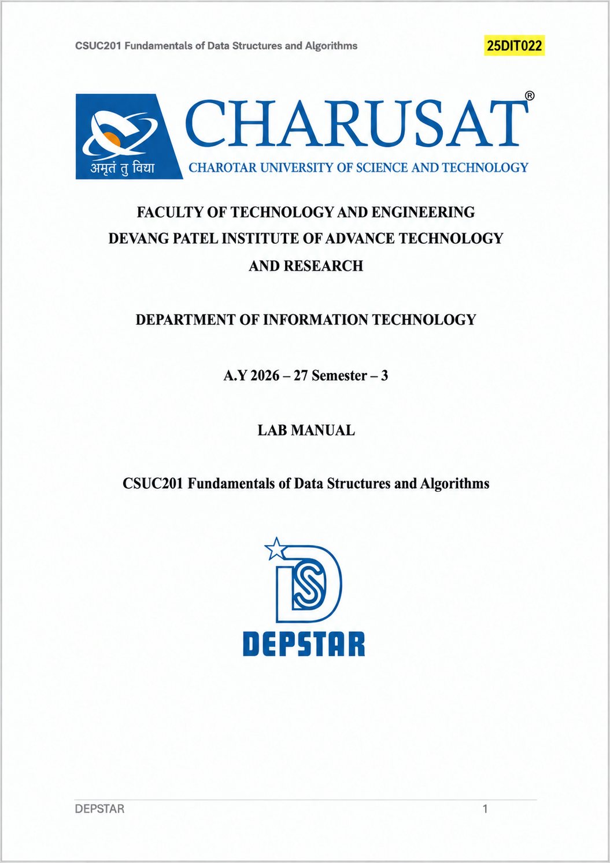
Practical-4.1
Github Link:
https://github.com/Harshjoshi871/FDSA_BATCH_A/tree/main/Practical%205
Difficulty :
Insert a song after a specific song and delete only the first song while keeping the playlist connected
Solution:
Find the given song and connect the new node between current and current->next. In a doubly linked list, we must update both next and prev links; if the song is not found, we do not insert anything.
Outcome:
The playlist worked correctly and all operations were performed successfully.

Code(Github) Link:
https://github.com/Harshjoshi871/FDSA_BATCH_A/blob/main/Practical%205/Practical%205.1.cpp
Output:
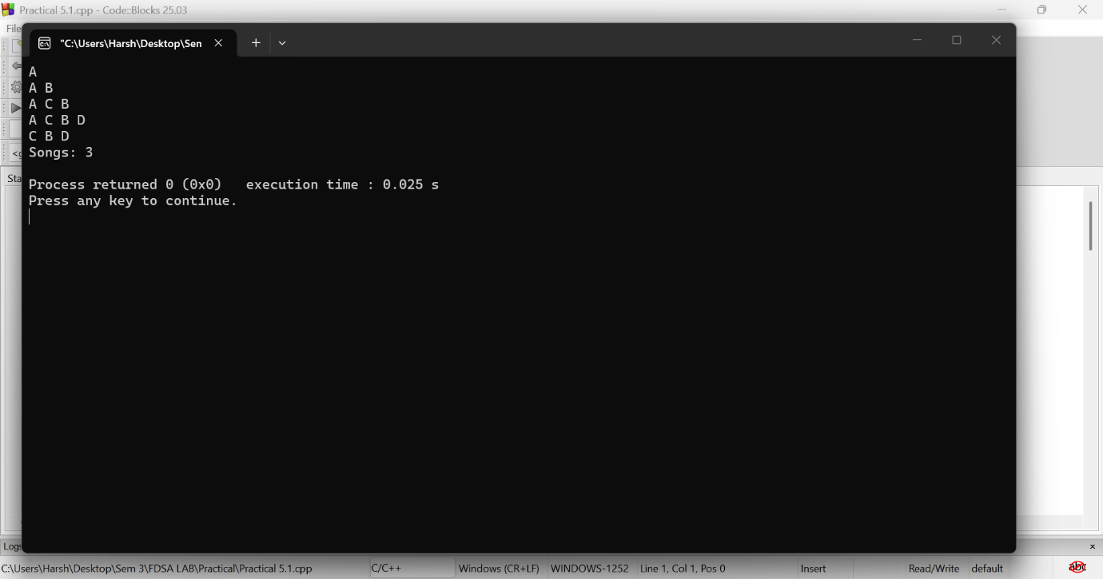
Key Question:
Problem-1
When deleting the front node, why does the second node's backward (prev) link create extra responsibility?
Answer:
When deleting the front node, the second node becomes the new head.
Its prev must be changed to NULL.
Otherwise, it will point to the deleted node, causing a dangling pointer.

Practical-4.2
Difficulty:
Students join/leave a circle, but the circle must never break.
Solution:
When deleting a student, connect the previous node directly to the next node and update the circular links. The biggest bug occurs when there is only one student, so we handle the single-node case separately.
Outcome:
The circular linked lists worked correctly.

Code(Github) Link:
https://github.com/Harshjoshi871/FDSA_BATCH_A/blob/main/Practical%205/Practical%205.2.cpp
Output:
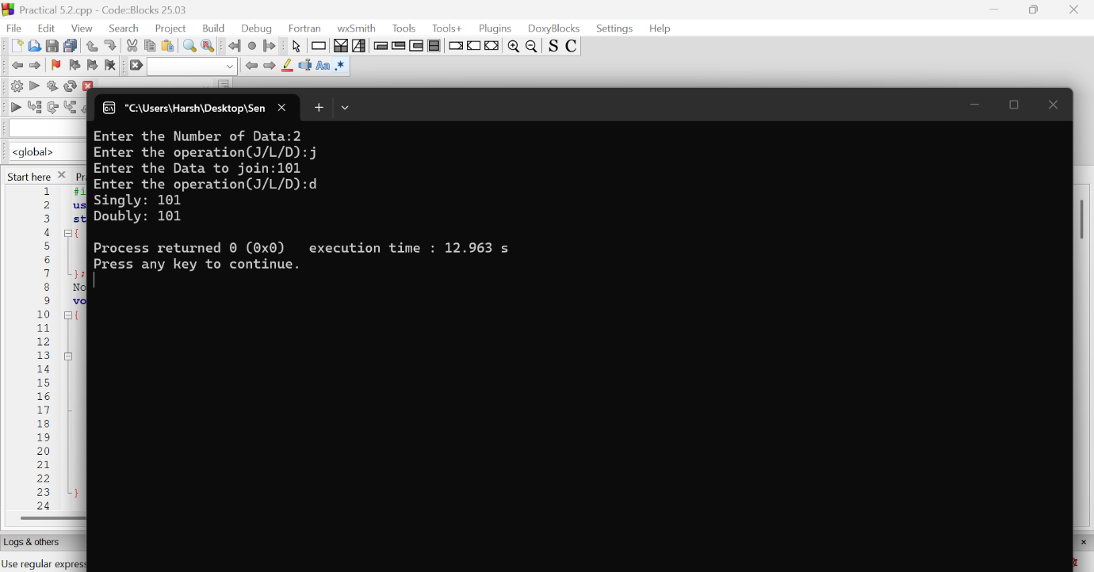

Key Question:
Problem-2:
Why can circular-list traversal loop forever?
Answer:
A circular linked list does not end with NULL; the last node points to the first.
So traversal should stop when temp == head.
Using temp != NULL would cause an infinite loop.

